GENAI
HANDSON
SRN: PES2UG23CS071
NAME: ANIRUDH MURALEEDHARAN
Seed = 42
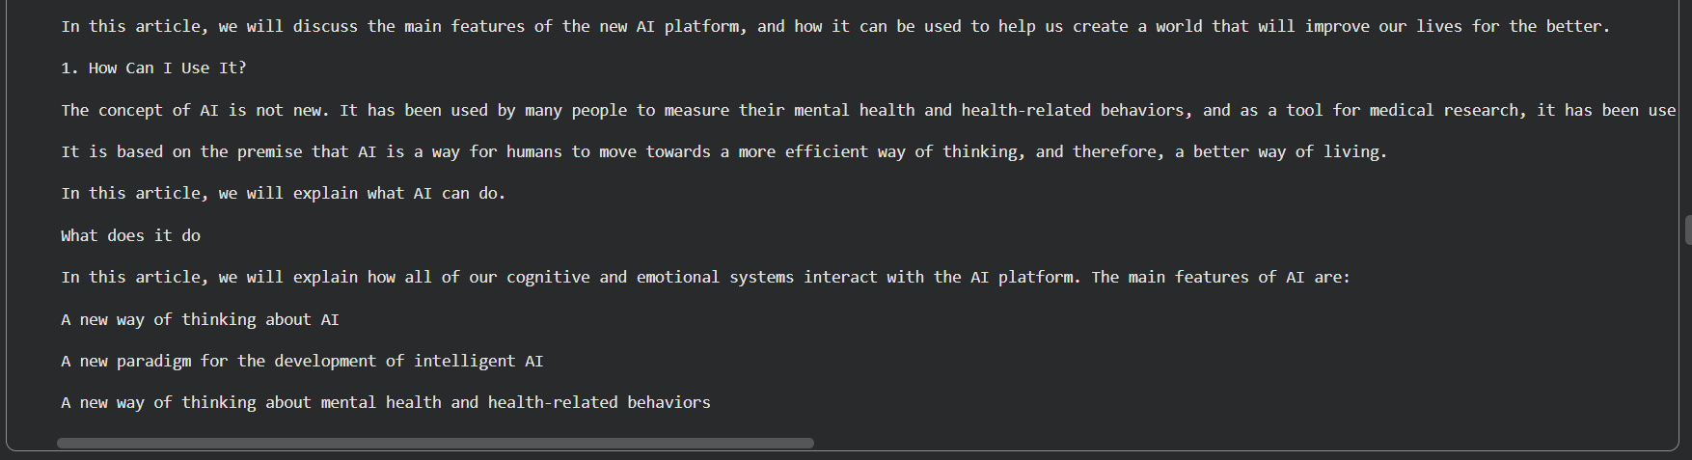

Seed = 48
Generative AI is a revolutionary technology that was developed in the 1950s for use in the production of novel biological systems, and now is one of the most influential developments in artificial intelligence and artificial intelligence research. It is a revolutionary technology that was developed in the 1950s for use in the production of novel biological systems, and now is one of the most influential developments in artificial intelligence and artificial intelligence research.

The study of the neural models of artificial intelligence (AI) has been done in the field of computational biology, and its methods for evaluating complex human-computer interactions have been adapted to include the analysis of neural networks as well, and its methods for the analysis of neural networks as well, have been adapted to include the analysis of neural networks as well, and its methods for the analysis of neural networks as well, have been adapted to include the analysis of neural networks as well, and is one of the most important contributions to the field of artificial intelligence research.

The study of the neural models of artificial intelligence (AI) has been done in the field of computational biology, and its methods for evaluating complex human-computer interactions have been adapted to include the analysis of neural networks as well, and its methods for the analysis of neural networks as well, have been adapted to include the analysis of neural networks as well

Distilled vs standard model
In brief: Distilled vs Standard Model
- Standard model:
Large, original model trained directly on data.
✔ Higher accuracy
❌ Slower, expensive, high memory
- Distilled model:
Smaller model trained to imitate a standard (teacher) model.
✔ Faster, cheaper, low memory
❌ Slightly lower accuracy
One-line exam answer:
A distilled model is a compressed version of a standard model that learns from the teacher model’s outputs to achieve faster inference with minimal loss in performance.
NER:
Named Entity Recognition is the process of identifying and classifying proper names in text into categories such as person, organization, location, and date

42 parts of speech depends on models
Tag | Meaning | Example
NN | Noun, singular | dog, model
NNS | Noun, plural | dogs, models
NNP | Proper noun, singular | India, OpenAI
NNPS | Proper noun, plural | Americans, Indians
Tag | Meaning | Example
VB | Verb (base form) | run, generate
VBD | Verb, past tense | ran
VBG | Verb, gerund/present participle | running
VBN | Verb, past participle | written
VBP | Verb, non-3rd person present | run (I run)
VBZ | Verb, 3rd person singular | runs (he runs)
Tag | Meaning | Example
JJ | Adjective | large, smart
JJR | Adjective, comparative | bigger
JJS | Adjective, superlative | biggest
RB | Adverb | quickly
RBR | Adverb, comparative | faster
RBS | Adverb, superlative | fastest
Etc

BERT is designed for deep language understanding, while GPT-2 is designed for fluent text generation

• Full form: Bidirectional and Auto-Regressive Transformers
• Architecture: Encoder–Decoder
• Training: Denoising autoencoder (corrupted text → original text)
• Best for: Text generation, summarization, translation

• BART:
A transformer model combining bidirectional encoding and autoregressive decoding, trained as a denoising autoencoder.
• BART vs BERT:
BART supports text generation using an encoder–decoder architecture, while BERT is encoder-only and designed for language understanding.

Aspect | BART | BERT
Architecture | Encoder–Decoder | Encoder-only
Directionality | Bidirectional + Auto-regressive | Bidirectional
Training objective | Denoising reconstruction | Masked Language Modeling
Text generation | ✅ Yes | ❌ No
Best for | Summarization, generation | Understanding tasks (NER, QA)
Hugging faces:
Hugging Face is a popular machine learning platform focused on natural language processing. It provides pre-trained models, datasets, and tools (like Transformers) that make it easy to build, train, and deploy ML models for tasks such as text generation, translation, and sentiment analysis.

